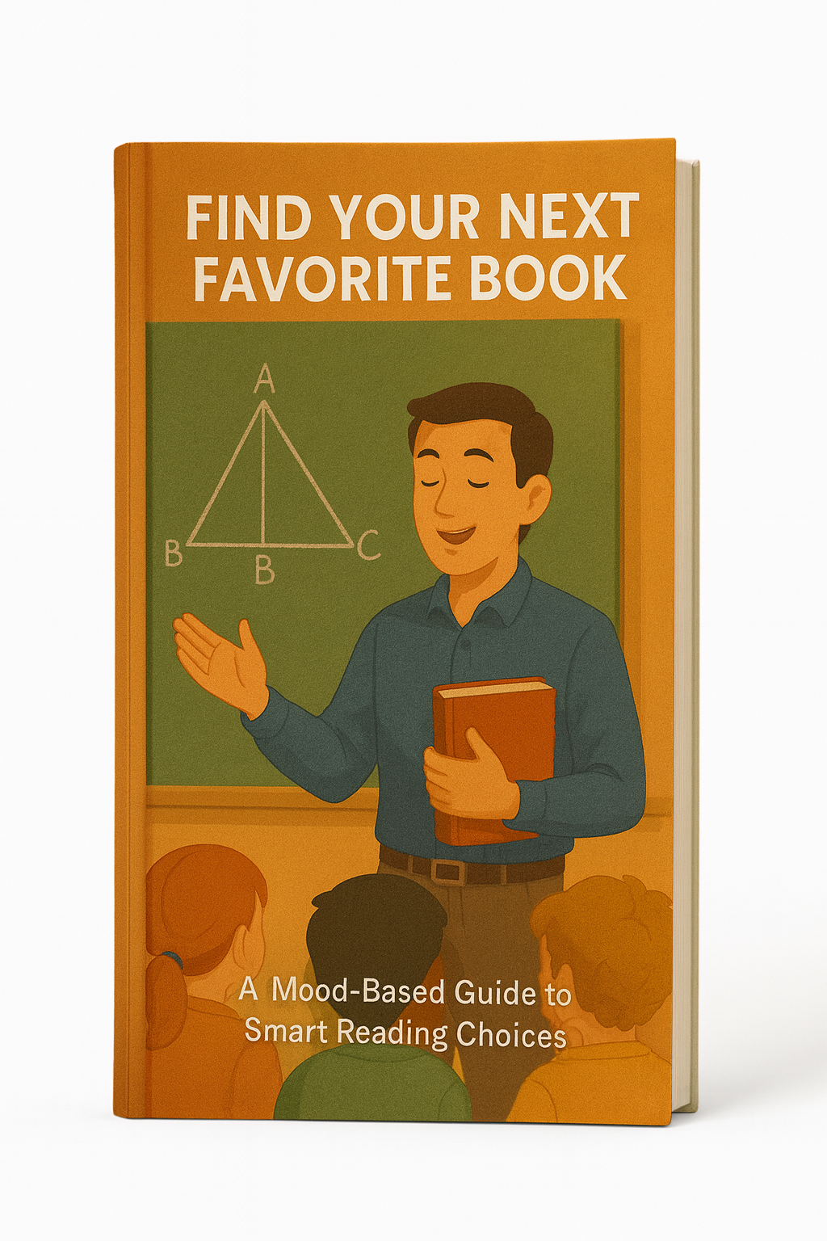

Find Your Next Favorite Book

A Mood-Based Guide to Smart Reading Choices

Table of Contents
Introduction – Why “What Should I Read Next?” Feels So Hard 3
Chapter 1 – Start With Your Mood, Not the Bestseller List 4
Chapter 2 – The Four Core Reading Moods 5
Chapter 3 – Matching Genres and Styles to Each Mood 7
Chapter 4 – A Simple Three-Step “Book Match” Method 9
Chapter 5 – Using Recommendations Without Getting Overwhelmed 11
Chapter 6 – Building Your Personal 90-Day Reading Map 13
Conclusion – Let Your Next Book Meet You Where You Are 15

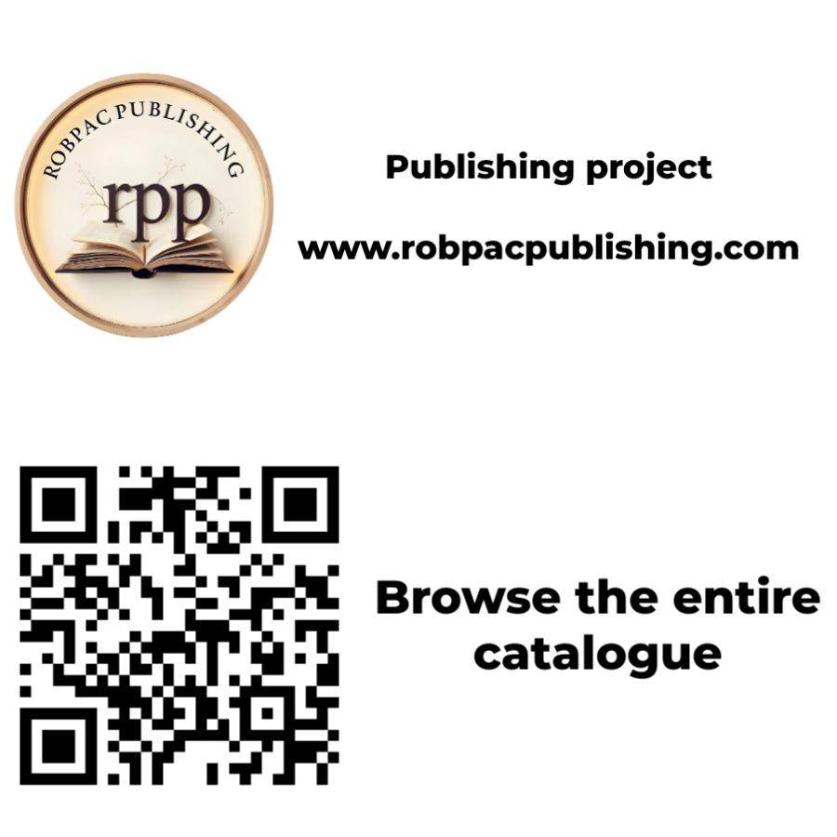

Introduction – Why “What Should I Read Next?” Feels So Hard

You would think that living in a world with millions of books should make it easy to find your next favorite one. In reality, the opposite often happens. You open a bookstore website, see endless covers and categories, and feel your brain freeze. Friends recommend titles, social media pushes new releases every week, and yet when you have an hour free, you still catch yourself scrolling instead of reading.
The problem is not that you are indecisive or unmotivated. It is that most recommendation systems are built around what is popular, not around how you actually feel today. Bestseller lists, awards, and “top ten” rankings can be useful, but they do not know whether you are tired, hopeful, stressed, curious, heartbroken, or ready for a challenge. They treat you as a data point, not as a person sitting on a couch at the end of a long day, with limited energy and a specific emotional weather inside.
Something else is happening too. You are facing what psychologists call “choice overload.” When you have too many options, it becomes harder to choose. Your brain starts running little simulations for each possibility: What if this book is slow? What if that one is too dark? What if I pick the wrong one and waste my time? This silent background analysis is exhausting. Often, to avoid the discomfort of choosing, you postpone the decision and default to whatever requires the least effort—usually a screen.
This guide flips the process. Instead of asking, “What is everyone else reading right now?” you will ask, “What mood am I in, and what kind of book matches that mood?” Once you start from your inner state rather than from the outside noise, choosing the right book becomes much easier, and the chance of a disappointing read drops dramatically. You stop treating reading like a performance in front of an invisible audience and start treating it like a gift you give to yourself.
Across the next chapters, you will learn to recognize your main reading moods, connect them to specific story types and non-fiction styles, and use a simple method to pick books that actually fit your life in this moment. You will also learn how to use recommendations without feeling buried by them and how to plan your next few reads in a way that feels flexible rather than rigid. Along the way, you will build a small but powerful reading roadmap for the next ninety days, so that you never have to stare at your shelves and wonder what to read next.
Your next favorite book is already out there. It may already be in your house, on your e-reader, or sitting on a library shelf a few blocks away. This guide will help you notice it when it appears and recognize it as yours.

Chapter 1 – Start With Your Mood, Not the Bestseller List

Most people choose books in one of three ways. They follow hype and pick the title everyone is talking about. They grab a book from a pile they bought months ago. Or they browse randomly until something catches their eye. Sometimes this works. Often it does not.
Think about the last time you abandoned a book halfway through. Was it truly a bad book, or was it simply the wrong book for your mood at the time? A dense political history may be brilliant, but if you are emotionally drained, you may not have the capacity it demands. A lighthearted romance might be perfect on a stressful week, but it feels too sweet when you crave depth and challenge. The book did not fail; the match between your inner state and the reading experience was off.
Mood-based reading starts from a different question: “What does my mind and heart need right now?” That question is surprisingly practical. It keeps you from forcing yourself into the wrong experience and helps you choose a book that can actually meet you where you are. It also reduces the silent self-criticism that often surrounds reading: the feeling that you “should” be reading something more serious, more trendy, or more impressive.
To make this work, you do not need a complex psychological system. You need the habit of pausing for a few seconds before you pick your next read. Instead of going straight to your list or your favorite online store, you take a breath and notice your emotional weather. Are you heavy or light, restless or focused, hopeful or discouraged? Are you hungry for comfort, distraction, challenge, or inspiration?
You might even take a moment to notice your physical state. Are you sleepy? Do you have a headache? Are you on a crowded train, in a quiet bedroom, or waiting in a doctor’s office? A book that works beautifully in a silent house on a Saturday morning might be completely wrong for fifteen minutes in a noisy environment.
Once you become aware of this inner landscape, you can match it to the right kind of story or non-fiction approach. Instead of treating books as fixed objects and yourself as a fixed reader, you begin to see both as parts of a moving relationship. The rest of this guide will give you clear categories and language for doing exactly that.

Chapter 2 – The Four Core Reading Moods

There are countless shades of emotion, but for the purpose of choosing what to read next, four core moods are especially helpful. Think of them as simple labels that describe what you are secretly asking a book to do for you. They are not boxes to lock yourself in; they are signposts pointing toward what might serve you best right now.
The first mood is Comfort. In this state, you want safety, warmth, and reassurance. You are not looking for big surprises or heavy topics. Perhaps life has been demanding, and you simply want to spend time in a world where people care for one another and things eventually turn out well. Comfort reading feels like a soft blanket and a familiar voice. It tells you, “You are not alone, and it is going to be okay.” For some people, comfort means gentle stories and kind characters. For others, it means returning to a favorite series they already know by heart, enjoying the predictability as a form of rest.
The second mood is Escape. Here, you want distance from your current reality. You are not necessarily unhappy; you just need to step outside your daily routines and responsibilities. You want to be absorbed so completely that hours disappear. High-stakes adventures, twisty plots, and vivid world-building tend to satisfy this mood. Escaping reading gives your brain a vacation. It offers different rules, different problems, and sometimes a different planet. It is especially powerful when your own life feels stuck, because it reminds you that other worlds and other possibilities exist.
The third mood is Growth. In this state, you are ready to be challenged. You want ideas, tools, and perspectives that stretch your mind. You may be working on a personal goal, a career change, or a new skill. Books that fit this mood do not have to be academic, but they should leave you with a sense that you learned something substantial. Growth reading often asks more of you. It may require concentration, note-taking, or reflection. The reward is a tangible sense of progress: new language for your experiences, new strategies for your problems, or new frameworks for understanding the world.
The fourth mood is Spark. Spark is different from steady growth. It is about inspiration, creativity, and the feeling of your inner life waking up. Maybe you feel dull, stuck in routines, or slightly bored with your own thoughts. You want books that make you see the world differently, that give you surprising connections and emotional electricity. Spark reading often lives at the intersections: essay collections that mix personal story and cultural commentary, books about art and creativity, unusual memoirs, or imaginative fiction that bends the rules. After Spark reading, you may find yourself wanting to write, draw, start a project, or have a long conversation.
On any given day, you might recognize yourself in more than one of these moods. That is fine. The point is not to label yourself permanently, but to notice which mood is loudest right now. If you know that you are craving comfort, reading a cold, technical manual will probably disappoint you, no matter how useful it might be in another season. If you feel energized and curious, a predictable story may leave you restless.
You can turn this into a fast ritual. Before choosing a book, ask: “On a scale from one to four, which of these moods is strongest: Comfort, Escape, Growth, or Spark?” You do not need to be precise. You just need a direction. As you practice, you will start to recognize patterns. You may notice that Sunday evenings call for comfort, long weekends invite growth, and travel days almost always require escape.
As you read the next chapters, you may already start linking these moods to specific books you have loved in the past. That is a sign that the framework is working. Your reading history becomes a resource, not just a list.

Chapter 3 – Matching Genres and Styles to Each Mood

Once you understand your current reading mood, you can begin to connect it to genres and styles that tend to satisfy that mood. These are not strict rules; they are starting points. What matters is how a book makes you feel, more than where a bookstore files it.
For Comfort, you will often find a good match in stories that center on relationships, community, and emotional resolution. Contemporary fiction set in small towns, gentle romances with hopeful endings, cozy mysteries where danger stays at a safe emotional distance, and heartwarming memoirs about overcoming challenges all fall into this category. Series with recurring characters can be especially soothing, because returning to them feels like visiting old friends. In non-fiction, comfort sometimes comes from reflective essays, spiritual or mindfulness writing, and books that offer reassurance rather than pressure. Even cookbooks, nature writing, or books about simple living can serve as comfort reads if they create a sense of calm.
When you are in an Escape mood, your best companions are stories with strong momentum and immersive settings. Fantasy and science fiction that build rich worlds, thrillers that move quickly and keep you guessing, historical novels that pull you into another time, and adventure narratives that cross oceans or galaxies all tend to work well. Short, punchy chapters and high stakes keep your attention locked in. Even within non-fiction, narrative history, true crime, or travel writing can provide this sense of stepping elsewhere. Audiobooks are particularly powerful for escape moods, because they let you sink into a different world while you walk, cook, or commute.
For Growth, look toward books that present clear ideas and practical frameworks. Personal development, psychology, career and business strategy, health and fitness, and skill-building guides are obvious candidates. Biographies of people who built something over time can also serve this mood, especially when they include honest lessons and concrete decisions, not just anecdotes. The key is that you close the book feeling more equipped than when you opened it. Many readers find it helpful to pair growth books with small actions: trying one exercise, applying one technique, or discussing one idea with a friend.
When your mood is Spark, you might reach for collections of thoughtful essays, creative non-fiction, books about art and creativity, or hybrid works that mix story and reflection. Poetic novels, literary fiction that experiments with structure, and cross-genre narratives can also light this spark, as long as they remain emotionally resonant. Visual elements—illustrations, photographs, diagrams—can add to the effect, because they engage different parts of your mind. Sometimes Spark books are the hardest to summarize but the easiest to remember, because they change how you pay attention.
Of course, genres can serve multiple moods depending on execution. A mystery can be cozy comfort or razor-sharp psychological tension. A memoir can be soothing or confrontational. A science book can be a strict growth or an unexpected spark. This is where paying attention to tone, pacing, and themes becomes crucial. When you read descriptions and sample pages, ask yourself, “Does this seem to offer the feeling I am asking for today?” If the answer is “maybe,” trust your instinct and give it a short trial.
With practice, you will develop your own personal map. Perhaps you discover that for comfort you love certain romance authors, for escape you prefer near-future sci-fi, for growth you gravitate toward psychology, and for spark you rely on essays by independent writers. The specifics are yours to customize. No algorithm can know these nuances as well as you can once you start paying attention.

Chapter 4 – A Simple Three-Step “Book Match” Method

Now that you have a language for moods and a sense of which genres usually fit them, you can apply a compact method each time you are ready for a new book. This three-step process takes only a few minutes but can save you weeks by helping you avoid the wrong choice.
The first step is to name your mood. Take a slow breath and ask honestly, “What am I hungry for right now: comfort, escape, growth, or spark?” You do not need a perfect answer. Just pick the one that feels closest, even if others are present in the background. If you feel torn between two moods, you can either choose the stronger one or plan to read two books in parallel, each serving a different need.
The second step is to narrow your field. Based on the mood you chose, please limit yourself to two or three genres or styles that typically serve it for you. If you are in a comfortable mood, you might decide to look only at contemporary fiction with hopeful endings or memoirs that focus on resilience. If you are in an escape mood, you could restrict your options to fantasy series and fast thrillers. If you want growth, you might focus on books recommended by people you respect in your field. The key is to shrink the universe of options so that your brain no longer feels overwhelmed.
The third step is to test with a short sample. Instead of committing unquestioningly based on a cover or a summary, give yourself five to ten minutes with the actual writing. Read a sample chapter, use the preview function on an online store, or flip through the first pages in a physical book. Pay attention not only to the plot, but to the energy of the prose. Does it pull you in quickly? Do you feel your shoulders drop, your curiosity rise, or your focus sharpen? Do you find yourself leaning closer or glancing away?
If the sample leaves you completely indifferent, that is useful information. You are free to set the book aside without guilt and move to the next candidate. Suppose it sparks genuine interest—even a small one—that is usually a good sign that the book is a strong match for your current mood. You are not trying to predict whether this will be the best book you read all year. You are simply choosing a companion for this particular stretch of your life.
Some readers like to add an optional fourth step: check the logistics. How long is the book? Is it available in the format you prefer—print, e-book, or audio? Do you already own it, or can you access it easily through a library or subscription? If a book feels like the perfect emotional match but is difficult to obtain right now, you can still add it to your future list and pick a more accessible option for the present.
Repeating this method a few times will give you a much higher “hit rate.” You will still occasionally choose something that does not land, but the percentage of books that feel like true companions will rise. Over time, the method becomes second nature: mood, narrow, sample, decide.

Chapter 5 – Using Recommendations Without Getting Overwhelmed

Friends, social media, book clubs, newsletters, librarians, and algorithms all love to recommend books. This flood of suggestions can be a blessing and a burden. On one hand, you discover titles you would never have found alone. On the other hand, your list grows faster than your capacity to read, and you may feel guilty for not keeping up.
Mood-based reading lets you take back control of recommendations rather than letting them control you. When someone suggests a book, your first internal question is not “Is this objectively good?” but “Which mood is this book likely to serve, and will that mood matter to me soon?” A dark, intense novel might be excellent, but if you are heading into a stressful work month, it may not be your immediate priority. A slim, hopeful memoir might suit you far better.
Suppose a trusted friend raves about a heavy, thought-provoking novel, and you are currently in a comfort zone. In that case, you can still appreciate the tip without forcing yourself to read it immediately. You simply mark it as a potential growth or spark book for another time. Conversely, if you are actively looking for a challenge, a long, complex work might finally be exactly right. The recommendation becomes raw material that you shape according to your own life, not a command you must obey.
Online platforms can also be filtered through this lens. Instead of saving every interesting title you see, you can group them according to mood. You might maintain four simple lists—Comfort, Escape, Growth, Spark—in a notes app, a reading tracker, or the “shelves” feature of a book site. That way, when you open your “to read” file, you are not staring at a chaotic list. You are selecting from a smaller set that matches how you feel today.
Book clubs and curated lists deserve special mention. They often blend different moods, which can be wonderful for broadening your horizons but frustrating if the group’s pick doesn't match your emotional state. It is perfectly acceptable to participate selectively, reading some selections now and saving others for a more suitable time. You might attend the discussion even if you did not finish the book, using it as a chance to discover whether the title might serve you later.
Librarians and independent booksellers are powerful allies in mood-based reading. Instead of asking, “What is popular right now?” you can say, “I am in the mood for something comforting but not too sweet,” or “I need a fast-paced escape that is not too violent,” or “I want a growth book that feels practical, not preachy.” Professionals who love books are often delighted to think in these terms, and their recommendations will be much more tailored.
The key is to remember that recommendations are invitations, not obligations. You owe no one an explanation for choosing a book that fits your present life over a book that would impress others. Your reading time is yours. When you treat it that way, the noise around books becomes background music instead of pressure.

Chapter 6 – Building Your Personal 90-Day Reading Map

So far, you have learned to choose books one at a time, guided by mood. Now is the time to expand your view and create a short-term reading map for the next 90 days. This is not a rigid schedule. It is a flexible plan that reduces decision fatigue and ensures that you always have several mood-appropriate options waiting.
Start by listing a small number of books you already own or are excited to access soon. Aim for variety: a couple of comfort reads, some escape adventures, one or two growth-focused titles, and at least one spark book that feels intriguing. Include both fiction and non-fiction if you enjoy both. Try to mix familiar authors with new voices. Remember to add works by independent authors, smaller presses, and voices that may not dominate the mainstream but resonate with you personally.
Next, assign each book a primary mood tag. You might write “comfort” beside a warm family saga, “escape” beside a space opera, “growth” beside a productivity guide, and “spark” beside an essay collection. Do not worry about being perfect. The goal is not academic classification; it is quick guidance for your future self. If a book seems to fit two moods, choose the one you are most likely to seek from it.
Then, look at your upcoming season of life. Are you heading into a stressful work period, a quieter month, or a time of transition? Use that knowledge to roughly estimate how much comfort, escape, growth, and spark you are likely to crave. If you expect high stress, you may want more comfort and escape titles in the next few weeks. If you feel stable and curious, you might plan for more growth and spark. If a major change is coming—a move, a new job, a new family member—you might choose books that support you emotionally through that transition.
Finally, place your chosen books in a loose sequence that feels balanced. For example, you might read a comfort novel, then a growth non-fiction book, then an escape adventure, then a spark essay collection. Or you might keep two parallel tracks: one comfort or escape book for evenings and one growth or spark book for mornings. You can jot this down as a simple list: “Next up: comfort title, then growth title, then spark title.” The point is not to lock yourself in but to always know where to look when you finish a book.
As new recommendations come in, you can add them to this map in the appropriate mood category, without disrupting the entire plan. If your feelings change unexpectedly—which they will—you are free to adjust. The map exists to serve you, not to trap you. If you planned for growth but life suddenly becomes overwhelming, you can temporarily shift into comfort mode and return to the other titles later.
Over time, this practice will give you a growing archive of books you have loved, organized not only by genre but by the role they played in your life. You will be able to say, “When I needed comfort, these stories held me,” or “When I was ready to grow, these authors guided me,” or “When I needed to remember that the world is bigger than my routine, these books gave me spark.” That is a deeper and more meaningful relationship with reading than any generic “top 100” list.

Conclusion – Let Your Next Book Meet You Where You Are

Finding your next favorite book is not about predicting what the world will celebrate. It is about noticing what your inner world needs, and then choosing a story or a set of ideas that can meet that need with honesty, skill, and heart.
When you pause to name your mood, match it to suitable genres and styles, sample before you commit, and build a simple ninety-day map, you turn reading from a random activity into a thoughtfully designed part of your life. You read with less guilt and more satisfaction. You finish more books that feel right for you. You quietly build a private library of experiences that have walked beside you through different seasons.
You also begin to trust yourself as a reader. You no longer wait for an expert, an algorithm, or a trend to tell you what belongs on your nightstand. You listen inward first, then look outward with clarity. Some books will still miss the mark, but many more will feel like exactly what you needed, exactly when you needed it.
The next time you ask, “What should I read now?” you will not be at the mercy of endless options. You will learn to listen inwardly, narrow your choices, and pick a book that fits who you are today.
And that is how your next favorite book finds you—and how you, in turn, keep finding the books that make your reading life feel alive.

